Sri Sathya Sai Loka Seva Gurukulam
Sathya Sai Grama, Muddenahalli, Chikkaballapur District – 562101, Karnataka State

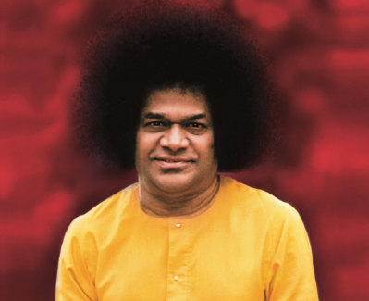 | 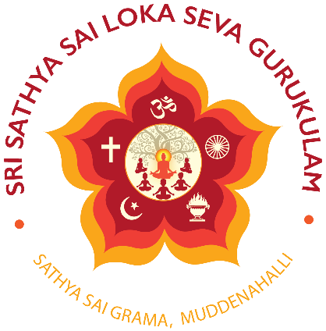 | 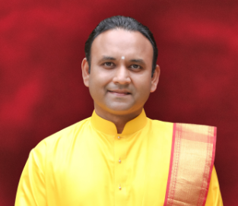
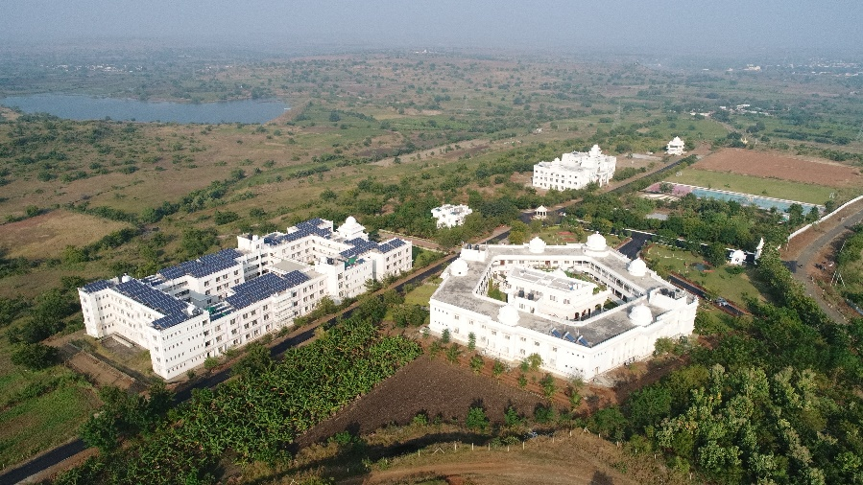
The right kind of education that teaches the science of the material world and also the science of spirituality by helping one realise one’s eternal Divine Self is the Indian Gurukulam System of Education

Uniqueness of Gurukulam
Our Gurukulam system is based on the philosophy of our Founder Sri Sathya Sai Baba who firmly believed that integrated development in children is possible only with the right balance of academic, moral and spiritual education. In the recent times, we have reviewed our approach and taken necessary steps to rededicate ourselves to our Founder’s vision, by imparting high quality academic education, by teaching sciences alongside spirituality, humanities alongside divinity, and excellence alongside enlightenment.

For the child to have a well-rounded personality and be able to withstand the pressures of life, in any progressive society, there needs to be equal emphasis on Physical, Intellectual, Emotional and Spiritual aspects. Unfortunately, some or the other aspect of this holistic education philosophy is found lacking in most of the present-day educational pedagogy due to its excessive focus on the academic aspect alone, and thus this needs immediate rectification. At SSSLSG, moral and spiritual education based on the Universal Human Values of Love, Right Conduct, Truth, Peace and Non-violence is imparted to students

In our Gurukula System, teachers live with students and nurture an atmosphere of learning and living with love.

Our Vision

​ To provide high quality, values-based holistic education, totally free of cost, to the deprived and needy rural children, in order to create strong individuals with brilliant Heads, compassionate Hearts and competent Hands.

sā vidyā yā vimuktaye - True Education is for Liberation

Our Mission

To support the setting up of one educational institution in each of the 600 plus districts of India, and imparting values-based holistic education free of cost, thus serving as a model for other institutions in that region.

The end of Education is Character and the end of Knowledge is love

Sri Sathya Sai Loka Seva Gurukulam
Sri Sathya Sai Loka Seva Gurukulam (SSSLSG) is a unit of Prashanthi Balamandira Trust (PBMT), which is a public charitable Trust, embedded firmly on the principles of Sri Sathya Sai Baba towards rendering selfless service to the rural needy, by bestowing a unique blend of spiritual and intellectual education.
sarve vedavidaḥ dhīrāḥ, sarve jñānōpa sampannaḥ,
sarve samuditā guṇaihi, sarve lōkahite ratāḥ

Devotion, Discipline, Love – A Means of Transformation

It is said there are two goals of education - jīvana upādhi, education that imparts knowledge and skills to lead lives, and jīvita paramāvadhi, Self-realisation, which is the ultimate goal of life. Students at the Sri Sathya Sai Loka Seva Gurukulam are exposed to a unique learning model that isn’t just limited to classrooms. From hostel rooms to dining halls to the playground, students are exposed to values and lessons everywhere – education with the heart.
Students are engaged at an intellectual, emotional, logical, ethical and spiritual level, inspiring and prodding them to always listen to, and act from the wisdom that’s latent within. Therefore, the unique feature of these Institutions is to impart sound, liberal, high quality ‘Man-Making’ education on modern lines, blending it with the noble values of Indian heritage in an atmosphere of Devotion, Discipline, Love and Mutual Cooperation. Sri Sathya Sai Baba, considered education, not as accumulation of information but rather a means of transformation
Affiliation to NIOS
All Students at Gurukulam will be studying under [NIOS] National Institute of Open Schooling system.
NIOS is an Autonomous Institute under Ministry of Education, Govt. of India
NIOS system which augurs well for our vision of balanced and holistic education, by helping reduce the stress of frequent assessment and examinations on our students, and allowing more flexibility in choosing subjects of one’s interest and inclination, leading to better performance.

Daily Routine Early to Rise and Early to Bed
The daily routine begins with chanting Suprabhatam at 5 a.m. and then undertaking yogasana, meditation, exercises etc. After breakfast, the academic classes begin from 8 a.m., with a one-hour break for lunch. Studies continue till 4 p.m., and this includes the time for practical work and study time as well.
Evening activities include outdoor games, followed by evening satsang and later study time for Indian Culture and Spirituality. Students go to bed early after a glass of milk and night prayers.

Eligibility for Admission
Students (Boys/Girls) who have passed 5th std / studying now and are born between 31 Mar 2011 and 31st Mar 2013 only can apply.

Admission
Register online at https://srisathyasailokasevagurukulam.org/admissions/ initial screening over telephone and then parent student interview at your preferred campus.Those qualified will proceed for next step of selection process

Seva Activities
Parents of students admitted to any of gurukulam are required to participate with “Seva Activities” of the Trust for two weeks in a year ( one week in the Sri Sathya Sai Salarala Memorial Hospital at Muddenahalli and other week in any of the nearest campuses/gurukulams or any of the trust services- Annapoorna breakfast seva, Sri Sathya Sai Sanjeevani Hospitals.]

Education is completely free
Students are not required to pay any fee for education, boarding and hostel accomodation

Joy of Learning
We firmly believe that in the coming decades stress in the life of a human being is only going to increase. So, there is a need to teach in the present-day schools how to cope with that. Research has shown that by and by, the Spiritual Quotient and the Emotional Quotient are becoming equally important, if not more important, than Intelligence Quotient. We take this responsibility very seriously to help the child develop the right behaviour which would create joy and happiness in his or her own life and in the life of those around him or her. Education experts define the most important skills for the twenty first century students of a global society, as the 4 C’s – critical thinking, communication, collaboration and creativity. But, we consider the 5th C – character over and above the 4 C’s, as the most important. Simply put, Character is the ability to do the right thing always. Understandably, all of this requires considerable time and focussed effort. Therefore, reducing the unwanted academic burden by enabling the child and the parents to choose the right subjects, based on child’s aptitude and interest, can help the child immensely, and allow enough time to learn other important skills, for not just surviving but thriving in the twenty first century

Photo Gallery

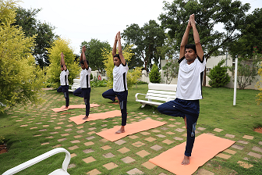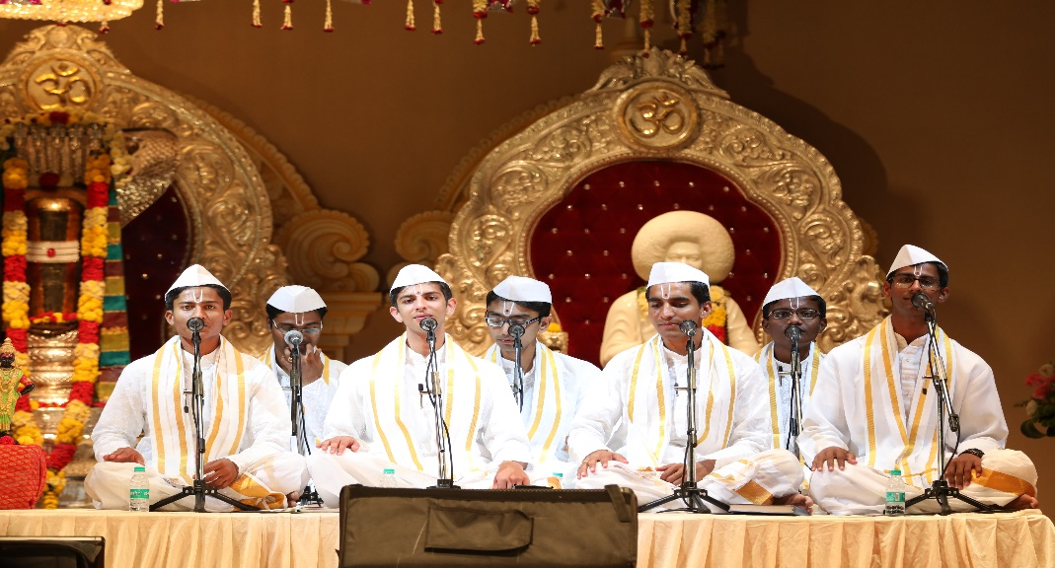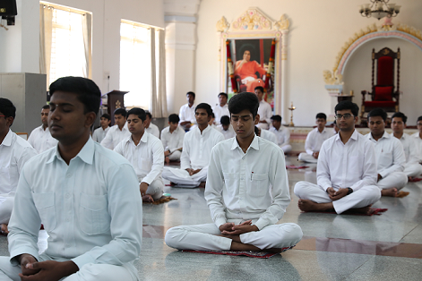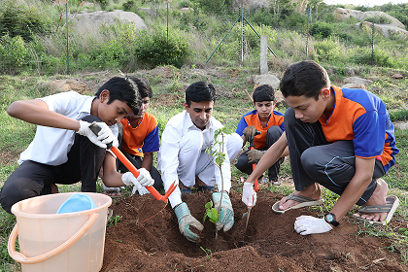

Boys Campuses
Kalaburagi: Sri Sathya Sai Vidyaniketanam,  Navanihala, Okali Post, Kamalapura, Kalaburagi District – 585313, Karnataka (Phone: 9986515663, 9535974309) |  | Vijayapura: Sri Sathya Sai Premaniketanam,  Anjutagi, Indi Taluk, Vijayapura District – 586204, Karnataka (Phone: 6363677734, 83108 68033)
Mandya: Sri Sathya Sai Sharadaniketanam Gurukulam,  Maradevanahalli Village, Maranachakanahalli Post  Dudda Hobli, Mandya Taluk and District - 571405,  Karnataka (Phone: 8197693176, 9740029457) |  | Koppal: Sri Sathya Sai Sevaniketanam,  Kudrikotgi, Malaka Samudra Post, Yalburga  Taluk, Koppal District – 583236, Karnataka  (Phone: 78997 14148, 63635 61504)
Vijayanagar: Sri Sathya Sai Vishwaniketanam,  Ingalagi, Kariganur Post, Kamalapura hobli, Hosapete Taluk, Vijayanagar District – 583223, Karnataka  (Phone: 919513886453) |  | Tumkur: Sri Sathya Sai Karunyaniketanam,  Ganadahunase Village, Sira Taluk, Tumkur  District – 572115, Karnataka  (Phone: 9449103145, 9482470951)
Belagavi: Sri Sathya Sai Nityaniketanam,  Garlgunji Village, Khanapur Taluk, Belagavi District -  591302, Karnataka (Phone: 8310281191,9902884807) |  | Karwar: Sri Sathya Sai Sattwaniketanam,  Belur Village, Karwar Taluk, Uttara Kannada District – 581400, Karnataka (Phone: 9242453243, 9972439173)
Chikkaballapur: Sri Sathya Sai Loka Seva Gurukulam, Sathya Sai Grama, Muddenahalli Post, Chikkaballapura District – 562101, Karnataka (Phone: 9108760062, 9901591032, 9440552611) |  | Hassan: Sri Sathya Sai Sathyaniketanam,  Channenahalli, Ibbeedu Post, Belur Taluk, Hassan District – 573216, Karnataka (Phone: 9113696162, 9663403996, 99016 48530)
Udupi: Sri Sathya Sai Ananyaniketanam,  Sri Sitarama Kalyan Mantapa, Near Srirama Mandir, Nada Badakeri Rd, Guddeangadi - Naada, Kundapur Taluk - 576224, Karnataka (Phone: 9481758414, 7795653432) |  | Chikkamagalur: Sri Sathya Sai Divyaniketanam,  Sringeri Road, Jayapura Post, Koppa Taluk,  Chikkamagalur District – 577123, Karnataka  (Phone: 8762882152, 9482422128)
Shivamogga: Sri Sathya Sai Sarvaniketanam Gurukulam,  Kamaruru Village, Bennuru Post, Chandragutti Hobli  Soraba Taluk, Shivamogga- 577429  (Phone: 9880440870, 9380092070) |  | Mysuru: Sri Sathya Sai Anantaniketanam  Kuvempu trust campus, Kannada Sahitya Parishat Road, Jayalakshmipuram, Mysuru, 570012  (Phone: 9740960037, 9380081948 , 8277343799)
Girls Campuses
Gadag: Sri Sathya Sai Vaniniketanam,  Majjur, Shirahatti Taluk, Gadag District -582120, Karnataka (Phone: 8548997123, 9148230594) | Chikkamagalur: Sri Sathya Sai Sriniketanam, Malige, Jayapura, Koppa Taluk, Chikkamagalur District - 577123, Karnataka (Phone: 7619185839, 8147951077)
Haveri: Sri Sathya Sai Vedaniketanam,Yatri Nivas building, Near Santa Shivayogi Sharifana Gaduge, At-Sharifgiri, Shishunala Village, Shiggaon Taluk, Haveri District – 581126, Karnataka (Phone: 8861499536, 81048 20527 and 9035307197). | Nallakadirenahalli, Chikkaballapur: Prashanthi Balamandira Girls High School & Kolar Campuses  (Phone: 9703529975, 9611445519, 9963613905)
Bengaluru Rural: Sri Satya Sai Gayatriniketanam,  Bengaluru Rural District – 561204, Karnataka (Phone: 7975048117, 8660028309) | Madurai: Sri Sathya Sai Meenakshiniketanam,  Sathya Sai Grama, Sevugampatty, Nilakkottai Taluk,  Dindigul District – 624211, Tamil Nadu  (Phone: 9578555000, 8248221016, 9443881558)
Kolar Campus being setup - now linked to existing campus for information & Preliminary Interview
Public Relations Office – Muddenahalli – 9449002130, 9380066253, 08154240700 ext.9016

Photo Gallery
